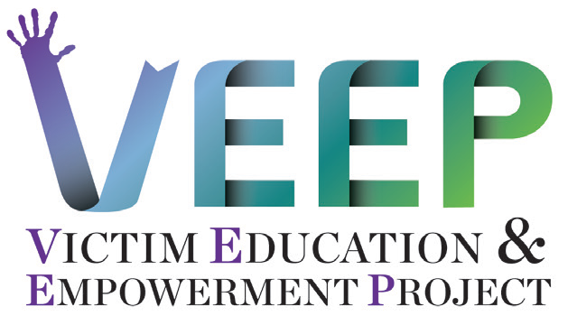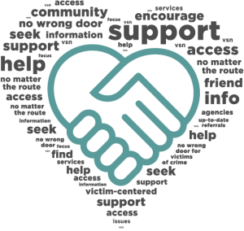

NC Youth Violence

Prevention Center

800 N. Walnut Street

Lumberton, NC 28358

Survivor Expression & Empowerment through Interactive Theatre (SEE-IT)

The 3rd type of service provides SEE-IT performances for the community. Groups of volunteers (all ages) create, rehearse and perform scenes where power imbalances are happening between characters. Audience members watch the performance to identify the conflict and figure out ways to empower victims in each scene. Volunteer actors listen to the audience and perform different endings. SEE-IT performances will happen in community and schools.

Earn an Upstander Certificate

Learn to safely act against bullying in your home, school, work place and community. Join a 4-week boot camp to become a certified Upstander in your community.

## Contact for Services, Training or Volunteering:

## Ashley Prows-Beard, LCSWA at (910) 733-8868

## Email: veepservices@gmail.com

Clients eligible for VEEP are victims of bullying, cyber-bullying, bystanders of bullying, dating violence, physical, psychological, sexual abuse, economic abuse, domestic violence, and other power-imbalance relationships.

Organizations eligible for trainings are law enforcement agencies and schools in Robeson, Richmond and Columbus Counties.

THE CLIENTS WE SERVE AT VEEP

The NC Youth Violence Prevention Center (NC-YVPC) in partnership with the NC Governor’s Crime Commission, offers a program for assisting and empowering victims of crime in 3 counties;

* Robeson
* Columbus
* Richmond

Violence can happen in the relationships with people we love, go to school with, and work with. Violence can happen in our homes, schools, work places and community.

**Victim Education & Empowerment Project (VEEP)**

The Victim Education & Empowerment Project (VEEP) offers three types of services.

Individual, Family, Group Counseling & Case Management

The 1st type of service provides free counseling to individuals, families and groups where there is an imbalance of power, making someone feel like a victim. Case management is available to assist with the basic needs of clients through available resources within the counties. Assistance with compensation paperwork and support during court appearances is available.

VEEP serves youth, adults and older adults of every race, ethnicity, religion, sexual orientation, gender expression, physical and neurological ability.

Training on Dynamics of Victimization

The 2nd service provides free training to organizations that employ law enforcement and school personnel on how to interact with victims and understand vulnerability without blaming the victim.