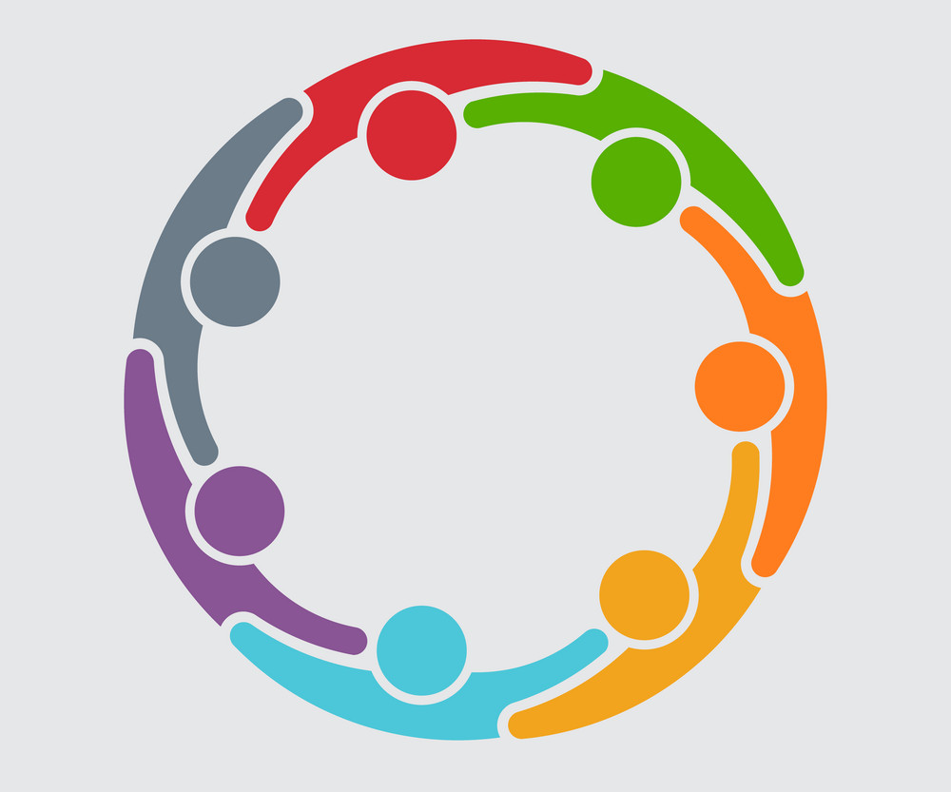

Family & Friends Circle of Support

This group is for family members and friends who care about someone that has been sexually assaulted. Be a part of this Circle of Support where your feelings are understood and your presence in the person’s life becomes part of their recovery. Give yourself this Circle of Support to end feelings of self-blame, shame and secrecy.
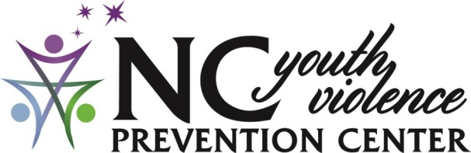
800 N. Walnut St., Lumberton, NC 28358

Redirecting Youth and Families Towards a Violence-Free Future
When Does Circle of Support begin? Ongoing

Where Does Circle of Support meet? On Zoom

What is Zoom?
A secure online video conferencing that you can join with the click of a link.

Who can join? Adults

Who are the facilitators?
Martica Bacallao, Ph.D., MSSW
Ashley Prows-Beard, LCSWA

How do I register?
Register with Ashley at 910-494-0615 or email ashley.prows@co.robeson.nc.us

What is the cost? This is a free service sponsored by the NC Governor’s Crime Commission

