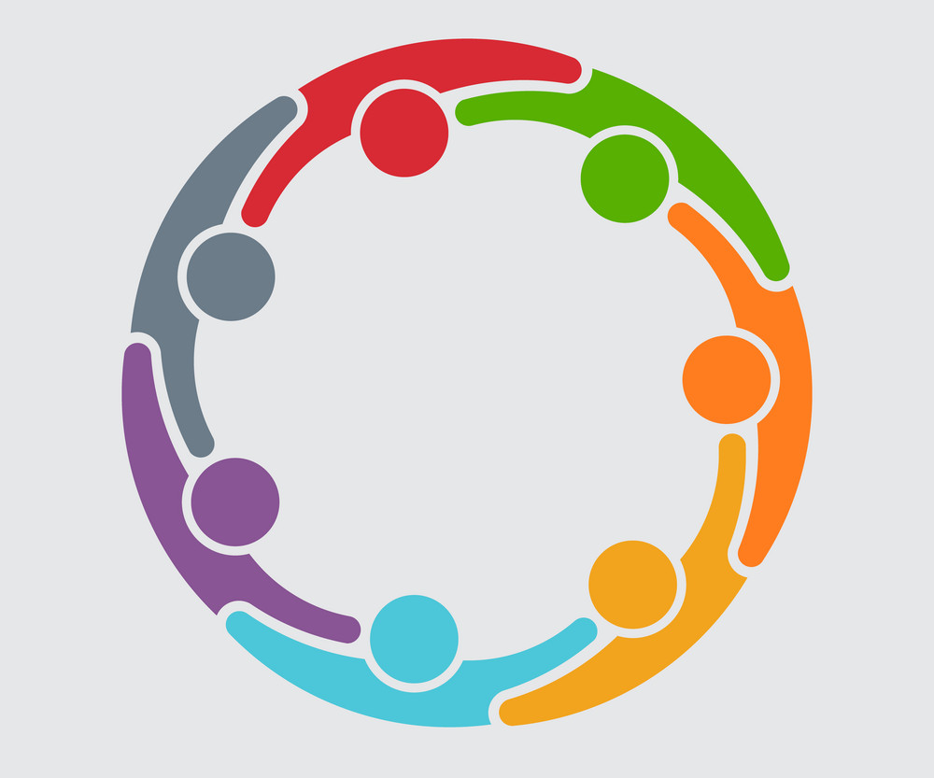

Adolescent Males Circle of Support

This group is for adolescent males who have experienced violence of any form. Be a part of this Circle of Support where you are heard and understood. Come join this Circle of Support to end feelings of self-blame, shame and secrecy.

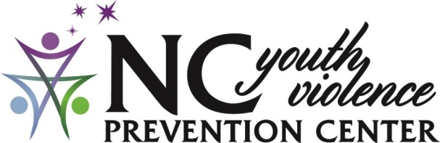
800 N. Walnut St., Lumberton, NC 28358

Redirecting Youth and Families Towards a Violence-Free Future
When Does Circle of Support begin? Ongoing

When Does Circle of Support end? 6 weeks after starting

Where Does Circle of Support meet? Zoom

What is Zoom?
A secure online video conferencing that you can join with the click of a link.

Who can join? Adolescent Males (Ages 12- 15)

Who are the facilitators?
Ashley Prows-Beard, LCSWA
Eddie Davenport, BSW

How do I register?
Register with Ashley at 910-494-0615 or email ashley.prows@co.robeson.nc.us

What is the cost? This is a FREE service sponsored by the NC Governor’s Crime Commission

